Al-Aqsa University – Gaza

Faculty of computer science
and information technology
Dep. Applied Science Technology

Graduation Project
Gaza Reconstruction Management &
Damage Assessment System (GRMDAS)
Prepared by students:
Students ID | Name Student
1301204963 | Talha Salah Mahmoud Siam

Supervised by:
Dr. Shadia Baroud
Dr.Raed Bulbul

A project report submitted in partial
fulfilment of the requirements for the award of
Bachelor of " Applied Science Technology "

2026-2025

DECLARATION

I hereby declare that this project report is based on my original work except for citations and quotations which have been duly acknowledged. I also declare that it has not been previously and concurrently submitted for any other degree or award at AL-Aqsa University.

Signature: ------------------------------------------
Name: -----------------------------------------------
ID No: -----------------------------------------------
Date: -------------------------------------------------

APPROVAL FOR SUBMISSION

I certify that this project report entitled “Gaza Reconstruction Management & Damage Assessment System (GRMDAS)” was prepared by Talha has met the required standard for submission in partial fulfilment of the requirements for the award of Bachelor at Al-Aqsa University of Computer Science.
Approved by,
Signature: ------------------------------------------
Name: -----------------------------------------------
Date: -------------------------------------------------

Dedication

We dedicate this project to everyone who has supported and encouraged us throughout our academic journey, and to our esteemed families, who have always been a source of inspiration and support. We also dedicate it to all our professors, who instilled in us a love of learning and knowledge and provided us with guidance and advice every step of the way.
We also dedicate it to our friends and colleagues at the university, who shared our challenges and successes. Their support has had a significant impact on the completion of this project.
We dedicate this project with respect and appreciation to everyone who believed in our abilities and supported us in reaching this stage.

Acknowledgments

We extend our sincere thanks and gratitude to our supervisor, Dr. Shadia Baroud, for his continuous support and valuable guidance throughout the preparation of this project.
We would also like to express our deep gratitude to all our professors in the Computer Information Systems Department for the knowledge and expertise they provided us, as well as their efforts, which have had a significant impact on developing our skills.
We should also not forget to express our appreciation and gratitude to our esteemed families, who have always supported us throughout this journey.
Our sincere thanks and appreciation to everyone who contributed in any way to the completion of this work.

Abstract

The recent conflict in the Gaza Strip has resulted in widespread destruction of residential and governmental infrastructure, creating an urgent need for a comprehensive mechanism to document and manage reconstruction efforts. This project presents the design and implementation of the "Gaza Reconstruction Management & Damage Assessment System (GRMDAS)," a web-based platform aimed at streamlining the process of reporting and assessing building damages.
The system addresses the chaotic nature of manual data collection by providing a centralized digital interface. It serves two main user groups: affected citizens and administrative personnel. Citizens can securely submit detailed reports regarding their damaged properties, including location, damage type (partial or total), and photographic evidence. On the administrative side, the system offers a robust dashboard equipped with statistical tools and decision-support capabilities. Administrators can verify submissions, update request statuses (Approved, Rejected, Pending), and visualize data through dynamic charts that categorize damages by type and status.
Technically, the system is built using PHP and MySQL for backend data management, ensuring data integrity and security. The frontend utilizes Bootstrap to guarantee a responsive user experience across various devices, supporting RTL (Right-to-Left) layout for Arabic language optimization. The GRMDAS project not only facilitates the efficient archiving of war damages but also provides decision-makers with accurate, real-time statistics to prioritize reconstruction projects, thereby contributing to a more organized and transparent recovery process.
Keywords: Reconstruction Management, Damage Assessment, Web Application, Gaza Strip, Data Visualization, Crisis Management System.

الملخص

أدى النزاع الأخير في قطاع غزة إلى دمار واسع النطاق في البنية التحتية السكنية والحكومية، مما خلق حاجة ملحة لآلية شاملة لتوثيق وإدارة جهود إعادة الإعمار. يقدم هذا المشروع تصميم وتطوير "نظام إدارة إعادة إعمار غزة وتقييم الأضرار (GRMDAS)"، وهو منصة تعتمد على الويب تهدف إلى تسهيل عملية الإبلاغ عن أضرار المباني وتقييمها.
يعالج النظام الطبيعة العشوائية لجمع البيانات يدوياً من خلال توفير واجهة رقمية مركزية. يخدم النظام فئتين رئيسيتين من المستخدمين: المواطنين المتضررين والطواقم الإدارية. يمكن للمواطنين تقديم تقارير مفصلة حول ممتلكاتهم المتضررة، بما في ذلك الموقع، نوع الضرر (كلي أو جزئي)، والأدلة المصورة. من الجانب الإداري، يوفر النظام لوحة تحكم متقدمة مزودة بأدوات إحصائية وقدرات لدعم اتخاذ القرار. يمكن للمسؤولين التحقق من الطلبات، وتحديث حالتها (مقبول، مرفوض، قيد المراجعة)، وتصور البيانات من خلال رسوم بيانية ديناميكية تصنف الأضرار حسب النوع والحالة.
من الناحية التقنية، تم بناء النظام باستخدام PHP وMySQL لإدارة البيانات الخلفية، مما يضمن سلامة البيانات وأمانها. تستخدم الواجهة الأمامية إطار عمل Bootstrap لضمان تجربة مستخدم متجاوبة عبر مختلف الأجهزة، مع دعم كامل لتخطيط RTL (من اليمين إلى اليسار) لتحسين اللغة العربية. لا يسهل مشروع GRMDAS أرشفة أضرار الحرب بكفاءة فحسب، بل يزود صناع القرار بإحصائيات دقيقة وفورية لتحديد أولويات مشاريع إعادة الإعمار، مما يساهم في عملية تعافٍ أكثر تنظيماً وشفافية.
الكلمات المفتاحية: إدارة إعادة الإعمار، تقييم الأضرار، تطبيقات الويب، قطاع غزة، تصور البيانات، نظام إدارة الأزمات.

Table of Contents

DECLARATION 2
APPROVAL FOR SUBMISSION 3
Dedication 4
Acknowledgments 5
Abstract 6
الملخص 7
Table of Contents 8
List Of Tables 11
List Of Figures 12
INTRODUCTION 13
1.1 Background 13
1.2 Problem Statement 14
1.3 Project Objectives 15
1.3.1 General Objective 15
1.3.2 Specific Objectives 15
1.4 Significance of the Study 16
1.5 Comparison between Manual and Digital Systems 16
1.6 Time Plan 17
1.7 Report Structure 17
Chapter 2 18
Theoretical Framework and Literature Review 18
2.1 Introduction 18
2.2 Theoretical Framework: Web Development Technologies 18
2.2.1 Hypertext Preprocessor (PHP) 18
2.2.2 HTML5 and CSS3 19
2.2.3 JavaScript (JS) and AJAX 19
2.2.4 Bootstrap 5 Framework 20
2.3 Theoretical Framework: Database Management System 20
2.3.1 MySQL 20
2.4 Theoretical Framework: Software Engineering Concepts 21
2.4.1 Client–Server Architecture 21
2.4.2 Model–View–Controller (MVC) Pattern (Loosely Applied) 21
2.5 Theoretical Framework: Development Tools 22
2.5.1 XAMPP Server 22
2.5.2 Visual Studio Code (VS Code) 22
2.6 Literature Review 22
2.6.1 Overview of Post-Disaster Reconstruction Systems 22
2.6.2 Existing Damage Assessment Tools 23
2.6.3 Web-Based Dashboards in Crisis Management 23
2.6.4 Identified Research Gap in the Gaza Context 23
Chapter 3 24
Methodology 24
3.1 Agile Development Methodology 24
3.2 Prototyping Methodology 25
3.3 Methodology Steps 26
3.4 Tools and Technologies 27
3.5 Comparative Analysis 27
3.6 System Architecture 29
Chapter 4 30
Implementation of Design 30
4.1 Introduction 30
4.2 UML Diagrams 31
4.3 User Interface Implementation 37
Chapter 5 43
Results and Discussion 43
5.2.1 Module Evaluation 43
5.2.2 Comprehensive Test Cases 45
5.3 Usability Assessment 45
5.3.1 User Interface Design 46
5.3.2 Cross-Platform Compatibility & Responsive Design 46
Chapter 6 48
Conclusion and Recommendation 48
References 51

List Of Table

Table 1 Manual vs Digital Systems 16
Table 2 Comparison of Technologies 27
Table 3 Comparison between Manual, Existing, and Proposed Systems 28
Table 4 Technology Comparison 28

List Of Figures

Figures 1 ER Diagram 31
Figures 2 Use Case Diagram 32
Figures 3Sequence Diagram 33
Figures 4 Class Diagram 34
Figures 5 State Diagram 35
Figures 6 Activity Diagram 36
Figures 7 Website Homepage 39
Figures 8 Login Page 40
Figures 9 Dashboard and Statistics 40
Figures 10 Management Users 41
Figures 11 Management Messages 41
Figures 12 Management Setting Website 42
Figures 13 Management Profile 42
Figures 14Comprehensive Test Cases 45

CHAPTER 1

INTRODUCTION

1.1 Background
The Gaza Strip has recently experienced severe armed conflict, resulting in extensive damage to residential buildings, government facilities, and essential public infrastructure. In post-conflict environments, reconstruction is a critical yet complex process that requires accurate data, efficient coordination, and transparent decision-making. However, damage assessment and reconstruction planning in Gaza currently rely heavily on manual procedures and fragmented digital tools, which often lead to data inconsistency, duplication, and delays in aid distribution.
To address these challenges, the Gaza Reconstruction Management System (GRMS) is proposed as a comprehensive web-based solution. The system aims to modernize the damage assessment process by providing a centralized platform for collecting, verifying, managing, and analyzing building damage data. By leveraging modern information technologies, GRMS seeks to support faster recovery efforts, improve coordination among stakeholders, and enhance transparency throughout the reconstruction phase.

1.2 Problem Statement
Despite the urgent need for efficient reconstruction management, there is currently no unified, automated system for managing damage assessment data in Gaza. This situation leads to several critical issues:
- Data Fragmentation: Damage information is dispersed across paper records, handwritten forms, and isolated spreadsheets, making data consolidation difficult.
- Lack of Real-time Insight: Decision-makers lack immediate access to accurate statistics regarding damage types, severity levels, and geographic distribution.
- Inefficient Workflow: Manual verification and approval processes are slow, labor-intensive, and highly susceptible to human error.
- Limited Transparency: Affected citizens have no reliable mechanism to track the status of their damage assessment or reconstruction requests.
Accordingly, this study seeks to answer the following research question:
How can a web-based management system streamline the damage assessment process and enhance the efficiency and transparency of reconstruction efforts in Gaza?

1.3 Project Objectives

1.3.1 General Objective
The primary objective of this project is to design and develop a secure, reliable, and user-friendly web-based system (GRMS) that centralizes the management of building damage data, thereby accelerating reconstruction efforts and ensuring fair and data-driven resource allocation.

1.3.2 Specific Objectives
The specific objectives of this project are as follows:
- Centralized Database: To develop a unified and secure database that stores all damage reports, including building location, ownership details, damage classification, and photographic evidence.
- Digital Submission Portal: To provide an accessible online interface that enables citizens to submit damage claims efficiently.
- Administrative Control Panel: To design an admin dashboard that allows authorized personnel to review, verify, approve, or reject claims systematically.
- Statistical Reporting: To implement real-time data visualization tools, such as charts and graphs, that categorize damage by type (total/partial) and ownership (government/private).
- Status Tracking: To enable citizens to track the real-time status of their submitted claims, ensuring transparency and accountability.

1.4 Significance of the Study
This project is significant on several levels:
- Operational Efficiency: The system significantly reduces processing time and administrative workload compared to traditional manual methods.
- Strategic Planning: It provides government authorities and international aid organizations with accurate, visualized data to prioritize reconstruction areas effectively.
- Social Impact: By offering transparency and clear communication channels, the system strengthens trust between citizens and reconstruction authorities.
- Academic Contribution: The project demonstrates the practical application of software engineering concepts in addressing real-world humanitarian and post-crisis challenges.

1.5 Comparison between Manual and Digital Systems
Feature | Manual System (Current) | Digital System (GRMS)
Data Storage | Paper files / Excel sheets (prone to loss) | Centralized secure database (MySQL)
Access Speed | Slow record retrieval | Instant search and filtering
Accuracy | High risk of human error and duplication | Automated validation and data integrity
Reporting | Manual and time-consuming | Real-time dashboards and auto-generated charts
Transparency | Low (no tracking mechanism) | High (online status tracking)
Security | Physically vulnerable | Encrypted passwords and role-based access
Table 1 Manual vs Digital Systems

1.6 Time Plan
The development of the GRMS follows a structured timeline divided into five main phases:
- Phase 1: Analysis (Weeks 1–2): Requirements gathering, stakeholder analysis, and system feasibility study.
- Phase 2: Design (Weeks 3–4): Database design (ERD), system architecture, and UI/UX prototyping.
- Phase 3: Development (Weeks 5–8): Backend implementation using PHP and MySQL, and frontend development.
- Phase 4: Testing (Weeks 9–10): Functional testing, debugging, and usability evaluation.
- Phase 5: Documentation (Weeks 11–12): Preparation of the final report and project presentation.

1.7 Report Structure
This report is organized into five chapters as follows:
- Chapter 1: Introduction
Presents the project background, problem statement, objectives, significance, system comparison, and development timeline.
- Chapter 2: Theoretical Framework and Literature Review
Reviews relevant concepts, technologies, and tools related to web-based systems, databases, and reconstruction management systems.
- Chapter 3: System Analysis and Design
Describes the system requirements, use case diagrams, database design (ERD), and overall system architecture.
- Chapter 4: System Implementation
Explains the development process, technologies used, and implementation details of the GRMS.
- Chapter 5: Testing, Results, and Conclusion
Presents system testing results, evaluates system performance, discusses findings, and concludes with recommendations for future

Chapter 2

Theoretical Framework and Literature Review

2.1 Introduction
This chapter presents the theoretical foundation upon which the Gaza Reconstruction Management System (GRMS) is developed. It is divided into two main sections. The first section, the Theoretical Framework, discusses the web technologies, database systems, and software engineering concepts employed in the system’s development. The second section, the Literature Review, examines previous studies and existing systems related to post-disaster reconstruction, damage assessment, and crisis management platforms, highlighting their relevance and limitations in relation to the proposed system.

2.2 Theoretical Framework: Web Development Technologies

2.2.1 Hypertext Preprocessor (PHP)
PHP is the primary server-side scripting language used to implement the backend logic of the GRMS.
- Role: PHP handles form processing, session management, user authentication, and interaction with the database.
- Justification: PHP was selected due to its strong compatibility with MySQL, wide support on web hosting platforms, and robust security features. In this project, the PDO (PHP Data Objects) extension is utilized to enhance security by preventing SQL injection attacks through prepared statements.

2.2.2 HTML5 and CSS3
- HTML5 (Hypertext Markup Language): HTML5 forms the structural foundation of the system’s web pages. Semantic elements are used to improve accessibility, maintainability, and search engine optimization (SEO).
- CSS3 (Cascading Style Sheets): CSS3 is responsible for the visual presentation of the system. Modern layout techniques such as Flexbox and Grid are employed to create responsive and organized page layouts.

2.2.3 JavaScript (JS) and AJAX
JavaScript is used to add interactivity and improve responsiveness on the client side.
- AJAX (Asynchronous JavaScript and XML): AJAX plays a critical role in enabling asynchronous data exchange between the client and server without requiring full page reloads. In GRMS, it is used in features such as the “Contact Us” form and administrative actions (e.g., deleting or updating records), providing a smoother, application-like user experience.
- SweetAlert2: SweetAlert2 is integrated to replace default browser alerts with customizable and responsive popup messages, improving usability and user feedback for both success and error notifications.

2.2.4 Bootstrap 5 Framework
Bootstrap 5 is used as the frontend framework for designing the user interface.
- Responsiveness: The Bootstrap grid system ensures that the application adapts seamlessly to various screen sizes, including desktops, tablets, and mobile devices.
- RTL Support: Native Right-to-Left (RTL) support is a critical feature for this project, allowing proper rendering of Arabic content and making Bootstrap 5 a suitable choice for the GRMS interface.

2.3 Theoretical Framework: Database Management System

2.3.1 MySQL
MySQL is the relational database management system (RDBMS) used to store and manage all system data.
- Database Structure: The GRMS database (gaza_builds) is designed using normalization principles to minimize redundancy and ensure data integrity. It includes interconnected tables such as buildings, admins, messages, and settings.
- Performance and Reliability: MySQL is widely recognized for its reliability, scalability, and efficiency in handling read-intensive operations, making it suitable for reporting dashboards and data analysis.

2.4 Theoretical Framework: Software Engineering Concepts

2.4.1 Client–Server Architecture
The GRMS is developed based on the Client–Server architecture model.
- Client: The web browser used by citizens and administrators to access the system interface and submit requests.
- Server: The Apache web server (via XAMPP) processes client requests using PHP scripts and communicates with the MySQL database.
This architecture ensures centralized data management and consistency, providing a reliable “single source of truth” for reconstruction-related information.

2.4.2 Model–View–Controller (MVC) Pattern (Loosely Applied)
Although the system does not use a full MVC framework such as Laravel, it follows the MVC concept in a simplified manner by separating responsibilities:
- Model: Database connection and data access files (e.g., db.php, SQL queries).
- View: User interface files that present data to users (e.g., index.php, admin/users.php).
- Controller: PHP scripts responsible for processing logic and user actions (e.g., process_building.php, update_status.php).
This separation improves code readability, maintainability, and scalability.

2.5 Theoretical Framework: Development Tools

2.5.1 XAMPP Server
XAMPP is used as the local development environment. It provides Apache, MySQL (MariaDB), and PHP in an integrated package, allowing efficient development, testing, and debugging before deployment.

2.5.2 Visual Studio Code (VS Code)
Visual Studio Code is used as the primary Integrated Development Environment (IDE). It was selected for its lightweight performance, extensive extension ecosystem (such as PHP and Prettier), and strong debugging support, which significantly enhanced development productivity.

2.6 Literature Review

2.6.1 Overview of Post-Disaster Reconstruction Systems
Post-disaster reconstruction is a complex and resource-intensive process that requires accurate data collection and coordination. Ophiyandri et al. (2013) emphasize that community-based reconstruction approaches are effective but often suffer from limited technological support. Traditional paper-based surveys are time-consuming, difficult to verify, and prone to data inconsistency. Recent research advocates the adoption of digital “e-Reconstruction” platforms to centralize data flow and improve coordination between affected populations and authorities.

2.6.2 Existing Damage Assessment Tools
Several digital tools are commonly used for damage assessment and humanitarian data collection, including KoBoToolbox and OpenDataKit (ODK).
- Strengths: These platforms support offline data collection, mobile surveys, and large-scale field assessments.
- Limitations: They generally lack integrated public portals for direct citizen submissions and do not provide customized administrative dashboards tailored to specific governmental workflows.
- Relevance to GRMS: In contrast, GRMS offers a complete, context-specific workflow (Submission → Review → Approval/Rejection) designed explicitly for reconstruction management in Gaza.

2.6.3 Web-Based Dashboards in Crisis Management
Bansal (2016) highlights the importance of web-based dashboards in crisis and disaster management, particularly for real-time monitoring and decision support. Visual representations such as charts and statistical summaries enable authorities to assess damage severity and allocate resources efficiently. GRMS adopts this approach by integrating real-time dashboards that present categorized damage statistics.

2.6.4 Identified Research Gap in the Gaza Context
Despite the availability of international systems, there is a lack of lightweight, localized platforms optimized for Arabic language support and Gaza’s administrative structure. Existing solutions are either overly simplistic (manual spreadsheets) or excessively complex (enterprise-level systems). The GRMS addresses this gap by providing a secure, user-friendly, and Arabic-compatible web-based system that balances simplicity with functionality.

Chapter 3

Methodology

3.1 Agile Development Methodology
The development of the Gaza Reconstruction Management System (GRMS) follows the Agile Development Methodology. This iterative and incremental approach was selected due to the evolving nature of system requirements, the need for continuous stakeholder feedback, and the importance of refining the Arabic Right-to-Left (RTL) administrative workflows and the “Deep Navy & Gold” user interface theme.
Agile enables flexibility by allowing changes to be incorporated throughout the development lifecycle rather than relying on a rigid, linear process. This approach ensures that functional components are delivered early and improved progressively.

Phases of Agile Development
- Requirements Analysis:
Core system requirements were identified, including damage reporting, reconstruction request management, administrative verification, and statistical dashboard generation. System stakeholders, namely citizens and administrators, were clearly defined.
- Design:
This phase focused on system architecture design, database schema development (gaza_builds), and UI/UX design using the Glassmorphism visual style.
- Development:
System features were implemented incrementally through short development cycles (sprints). For example, the “Contact Us” module was completed, tested, and integrated before proceeding to the “Building Damage Request” module.

- Testing:
Continuous testing was performed after each iteration to verify system functionality, including AJAX interactions, database insertions, and user interface responsiveness.
- Deployment:
The system was deployed on a local server environment using XAMPP for final validation and demonstration.
- Review and Refinement:
Feedback from each iteration was used to improve usability and design aspects, such as optimizing sidebar width and enhancing color contrast for better readability.

3.2 Prototyping Methodology
To ensure that the user interface meets the practical needs of Gaza’s community and administrative users, a Prototyping Methodology was integrated within the Agile framework. This approach allowed early visualization of the system and rapid refinement based on feedback.
Phases of Prototyping
- Requirement Gathering:
Emphasis was placed on Arabic language support, RTL layout, accessibility, and color psychology (Navy symbolizing trust and stability, and Gold representing hope and recovery).
- Quick Design:
Initial wireframes for dashboards and forms were created using HTML and Bootstrap.
- Prototype Development:
A high-fidelity functional prototype was developed, incorporating Glass morphism effects and a responsive navigation sidebar.
- User Evaluation:
The prototype was evaluated using simulated users to assess navigation flow, form usability, and RTL alignment.
- Prototype Refinement:
Layout adjustments and CSS improvements were applied based on feedback, such as resolving table overflow issues on mobile screens.
- Final Implementation:
The approved prototype was converted into the final production-ready PHP code.

3.3 Methodology Steps
The overall project lifecycle followed a structured sequence of steps:
- Problem Definition:
Identification of the absence of a centralized digital system for managing damage assessment and reconstruction in Gaza.
- Feasibility Study:
Evaluation of technical and economic feasibility, confirming that a web-based solution using PHP and MySQL is cost-effective and accessible.
- System Analysis:
Definition of system actors (Administrator and Citizen) and core use cases such as submitting damage reports and approving requests.
- System Design:
Design of the Entity Relationship Diagram (ERD) and overall system architecture.
- Implementation:
Development of backend functionalities using PHP and frontend interfaces using HTML, CSS, and JavaScript.
- Testing and Validation:
Execution of unit testing for individual components and integration testing to validate complete system workflows.

3.4 Tools and Technologies
The tools and technologies were selected based on performance, ease of deployment, cost efficiency, and suitability for Arabic-language systems.
Component | Selected Technology | Alternative | Reason for Selection
Backend | PHP | Node.js | Wide hosting support, strong MySQL integration, and simplicity
Database | MySQL (MariaDB) | MongoDB | Relational structure supports complex relationships
Frontend | Bootstrap 5 | Tailwind CSS | Built-in RTL support and rapid UI development
Server | Apache (XAMPP) | Nginx | Easy local setup for development and testing
Interactivity | SweetAlert2 | Native Alerts | Enhanced user experience with modern UI feedback

Table 2 Comparison of Technologies

3.5 Comparative Analysis
A comparative analysis was conducted to justify the development of GRMS in comparison to manual systems and generic digital tools.

Feature | Manual System | Existing Generic Tools | Proposed System (GRMS)
Data Entry | Slow and error-prone | Fast but disconnected | Real-time validated forms
Data Storage | Physical files | Scattered cloud files | Centralized MySQL database
Accessibility | Location-bound | Public or link-based | Role-based access control
Reporting | Manual and time-consuming | Basic charts | Automated real-time dashboards
User Feedback | Delayed or none | Manual follow-up | Instant alerts and status tracking
Language Support | Arabic (handwritten) | Inconsistent | Native Arabic (RTL) optimized

Table 3 Comparison between Manual, Existing, and Proposed Systems

Feature | PHP | Python (Django) | ASP.NET
Cost | Open Source | Open Source | Licensing dependent
Hosting | Widely supported | Requires configuration | Windows-centric
Performance | High for CRUD systems | Moderate | High
Community Support | Very large | Growing | Enterprise-focused

Table 4 Technology Comparison

3.6 System Architecture
The GRMS follows a three-tier architecture to ensure scalability, maintainability, and modular design.
- Presentation Layer (Client Side):
  - Technologies: HTML5, CSS3, Bootstrap, JavaScript
  - Function: Displays user interfaces such as forms, tables, and dashboards. Handles client-side validation and AJAX requests.
- Application Layer (Server Side):
  - Technologies: PHP
  - Function: Processes HTTP requests, enforces business logic, validates inputs, and manages user authentication and authorization.
- Data Layer (Database Side):
  - Technologies: MySQL
  - Function: Stores and retrieves system data while maintaining data integrity through primary and foreign key constraints.
This layered architecture allows independent modification of system components. For example, user interface themes can be updated without impacting backend logic or database structure.

Chapter 4

Implementation of Design

4.1 Introduction
This chapter presents the practical implementation of the system design derived from the analysis phase. It translates the functional and non-functional requirements into an executable technical structure. The chapter utilizes Unified Modeling Language (UML) diagrams to visually represent system behavior, component interaction, database structure, and process workflows.
The following UML diagrams are included to provide a comprehensive understanding of the system implementation:
- Use Case Diagram: Illustrates interactions between system actors (Administrator and Citizen) and system functionalities.
- Class Diagram: Represents the logical structure of the system database and the relationships between its entities.
- Sequence Diagram: Demonstrates the chronological sequence of operations for a selected scenario (approving a building request).
- State Diagram: Describes the lifecycle states of a building damage request.
- Activity Diagram: Explains the workflow involved in submitting a new damage report.

4.2 UML Diagrams

4.2.1 ER Diagram

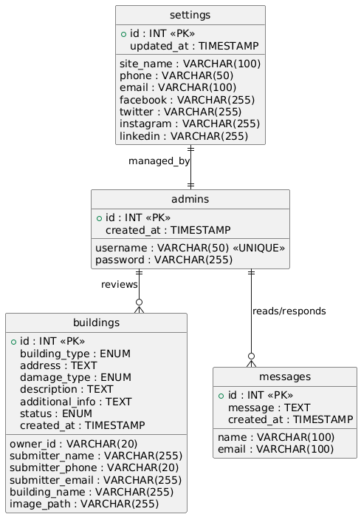
Figures 1 ER Diagram

4.2.2 Use Case Diagram

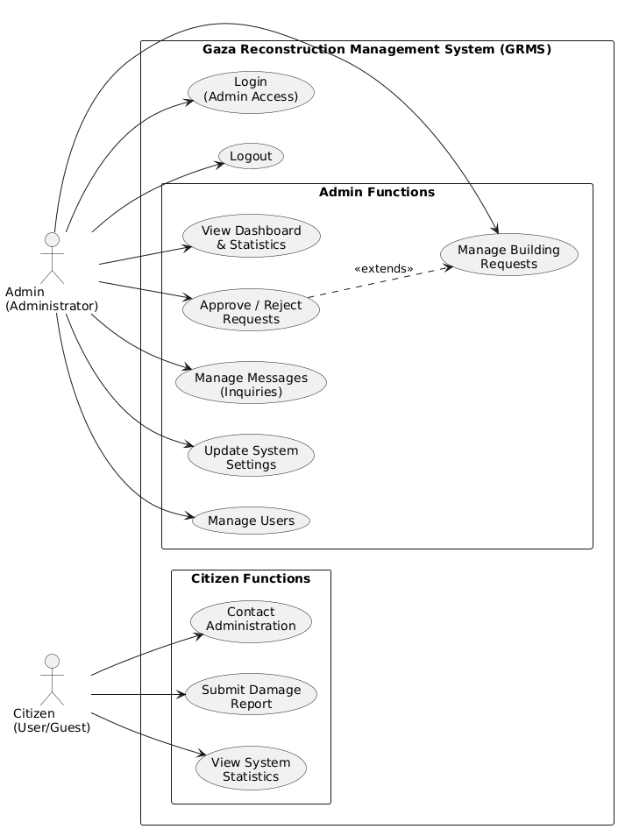
Figures 2 Use Case Diagram

4.2.3 Sequence Diagram

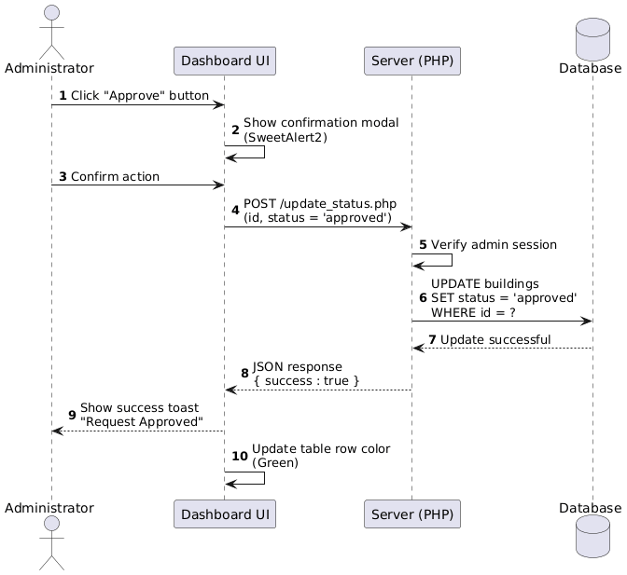
Figures 3Sequence Diagram

4.2.4 Class Diagram

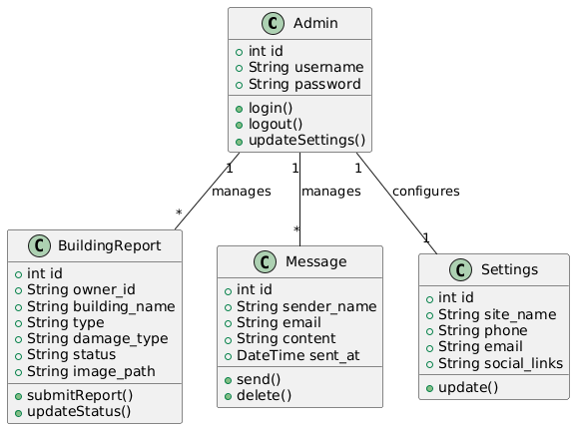
Figures 4 Class Diagram

4.2.5 State Diagram

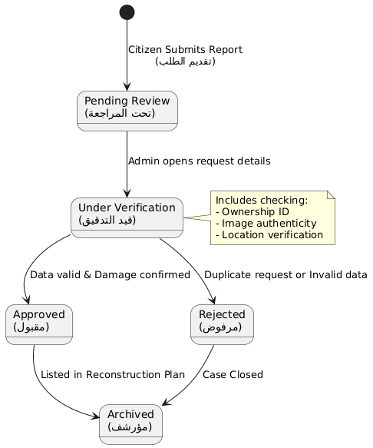
Figures 5 State Diagram

4.2.6 Activity Diagram
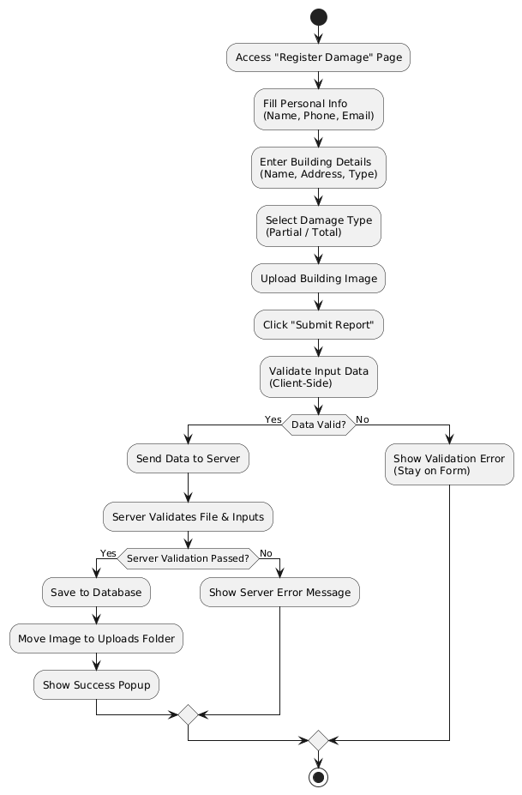
Figures 6 Activity Diagram

4.3 User Interface Implementation

4.3.1 Home Page

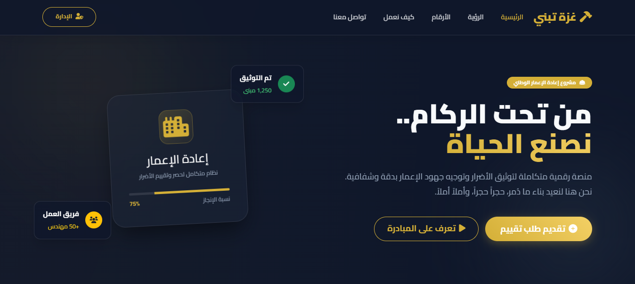

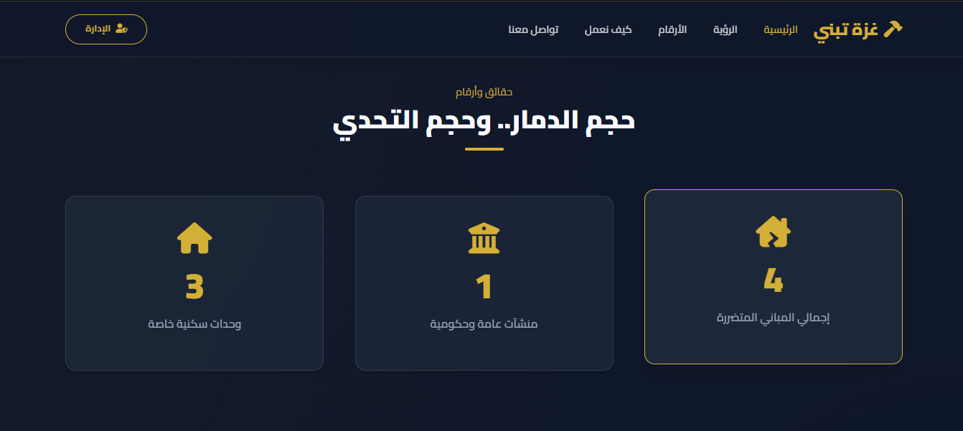

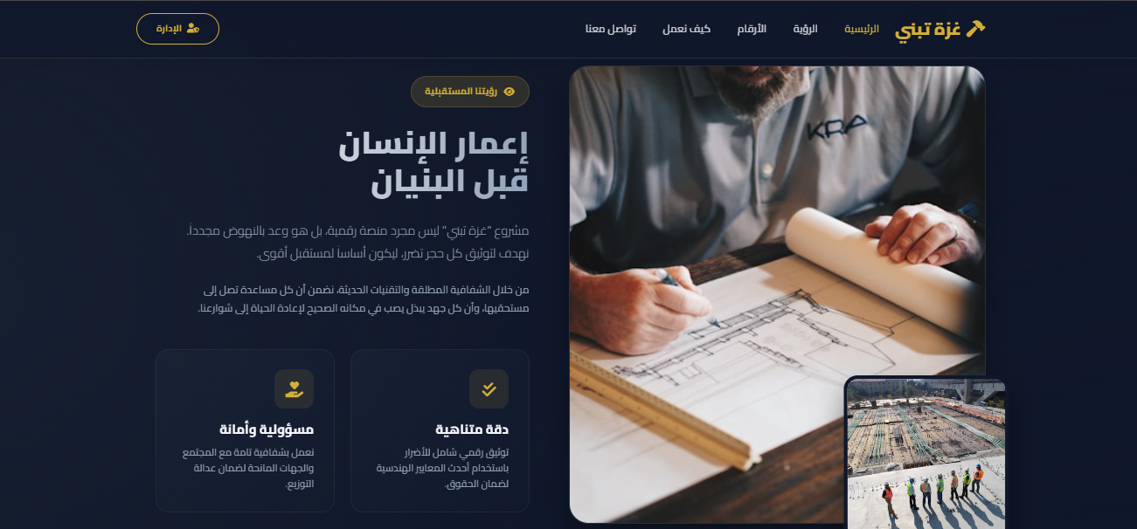
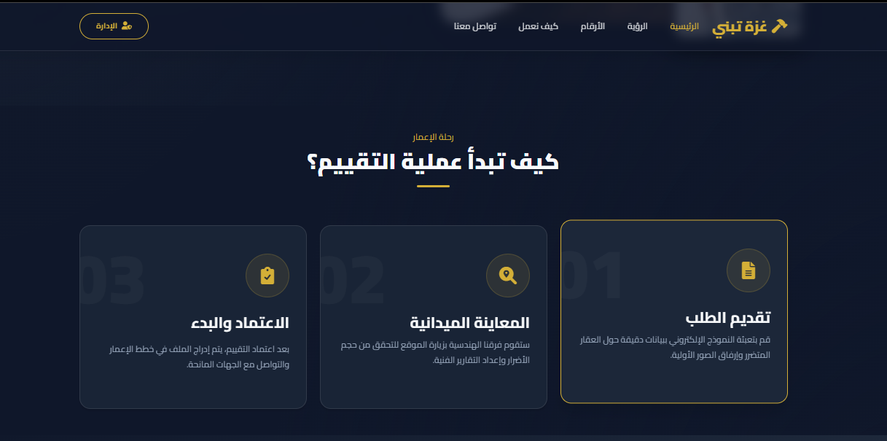

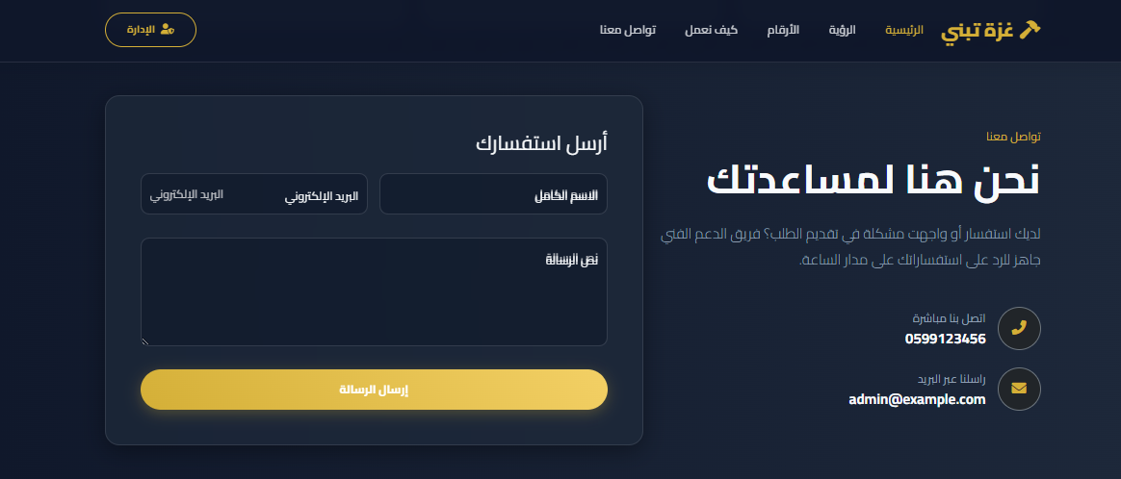
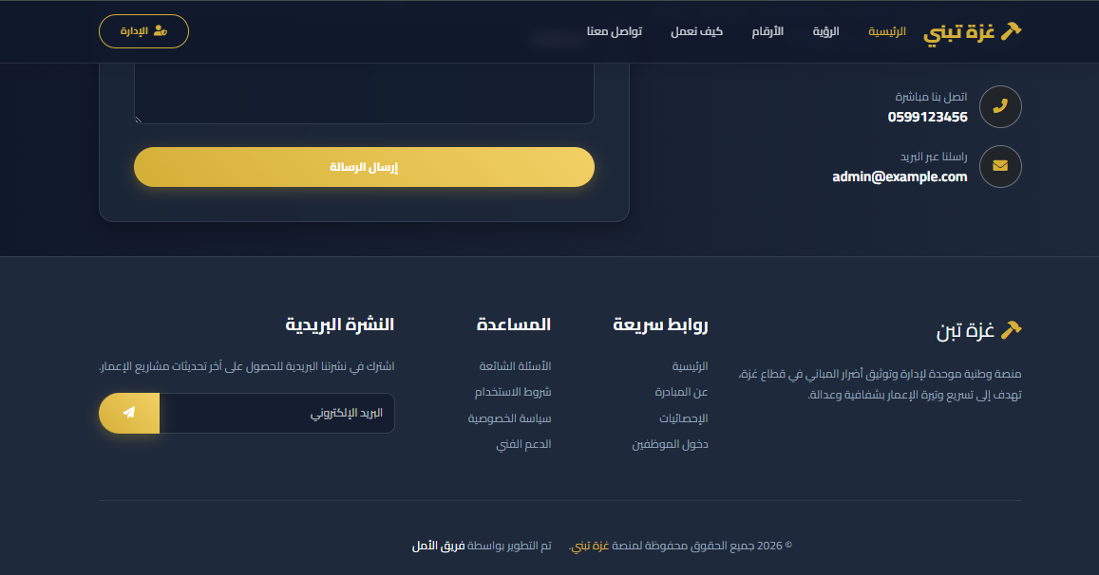
Figures 7 Website Homepage

4.3.2 Login Page

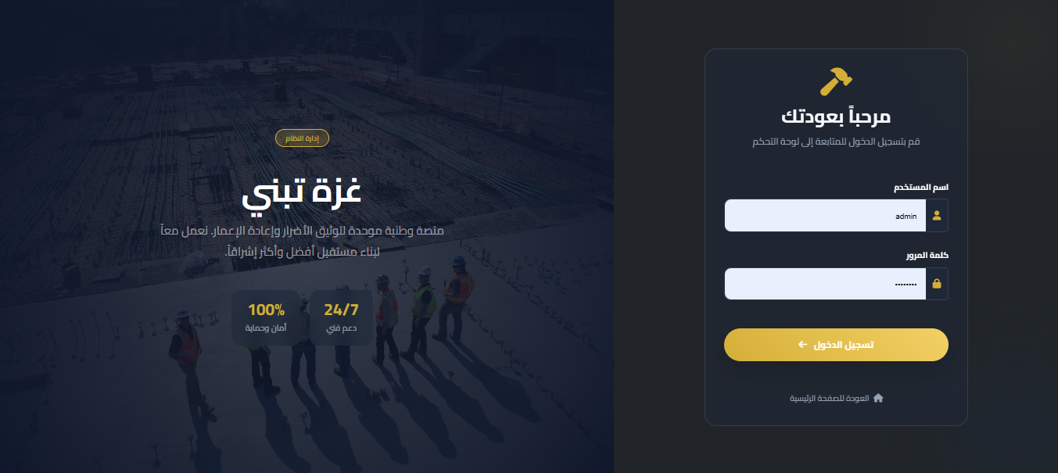
Figures 8 Login Page

4.3.3 Admin Dashboard

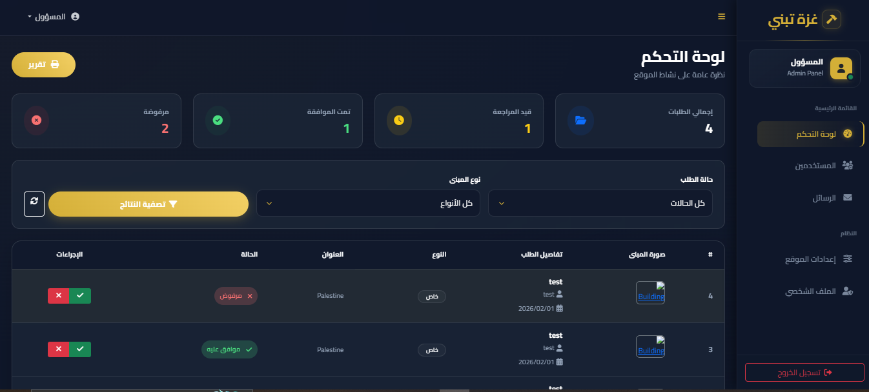
Figures 9 Dashboard and Statistics

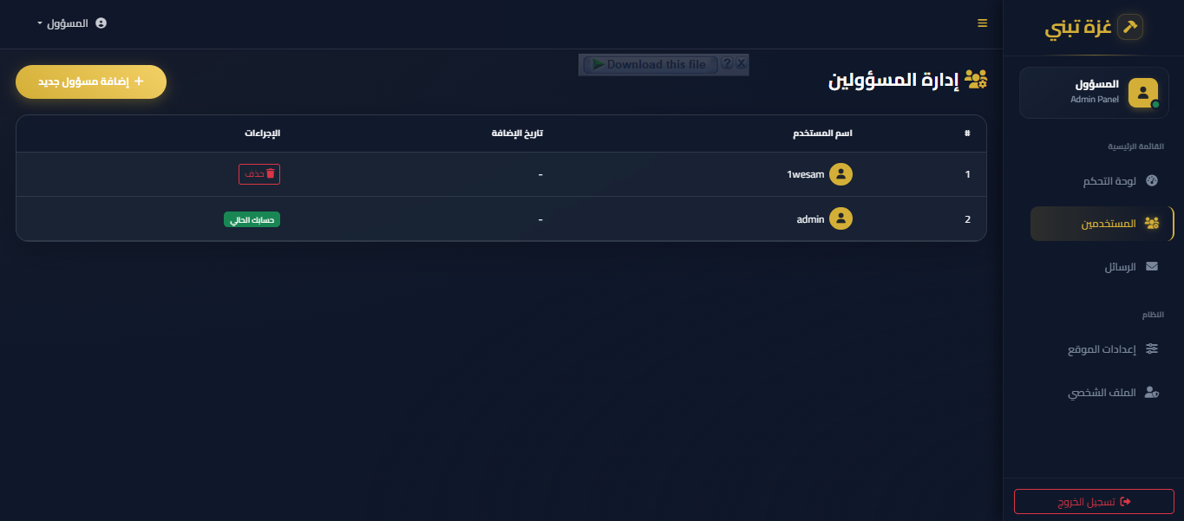
Figures 10 Management Users

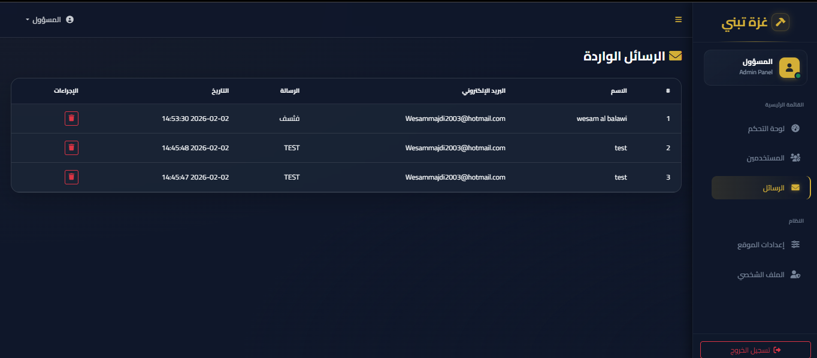
Figures 11 Management Messages

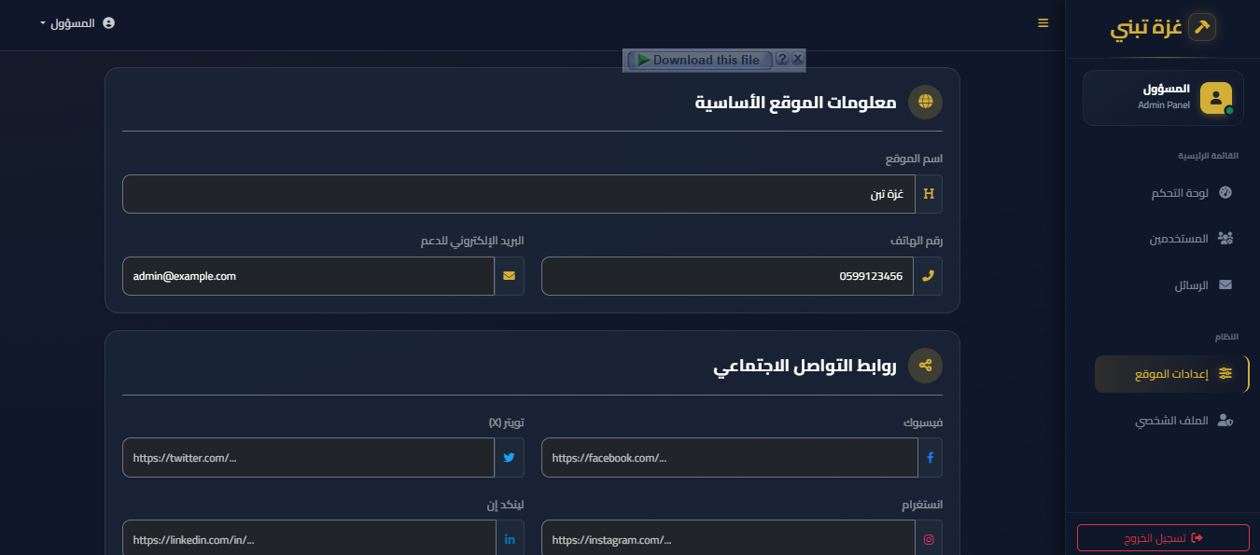
Figures 12 Management Setting Website
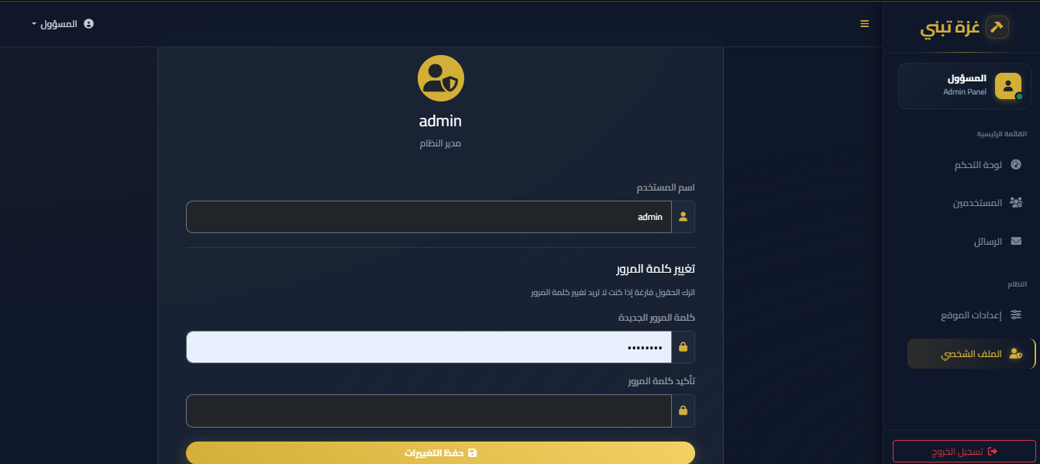
Figures 13 Management Profile

Chapter 5

Results and Discussion

5.1 Introduction
This chapter presents the results of the implementation and testing of the "Gaza Builds" (Gaza Reconstruction Management System). It provides a comprehensive evaluation of the system's functionality, usability, and performance. The main objective is to verify that the developed system fulfills the requirements defined in the analysis phase and effectively addresses the challenges of managing post-conflict reconstruction data. The chapter covers functional testing of individual modules, usability assessments of the user interface, and cross-platform compatibility checks.

5.2 Functional Assessment
Functional assessment focuses on verifying that the system performs its intended operations accurately and reliably. This involves evaluating key modules and conducting rigorous test cases.

5.2.1 Module Evaluation
The system is organized into several core modules, each designed to support a specific aspect of the reconstruction workflow.
- Public Request Submission Module
  - Functionality: Allows citizens to submit damage reports through a multi-step wizard (Verification, Personal Info, Building Info, Additional Details).
  - Result: Validates user input successfully, securely handles image uploads, and stores data in the MySQL database. The "Check Previous Request" feature correctly identifies existing records to prevent duplicates.
  - Status: Pass
- Admin Dashboard & Authentication Module
  - Functionality: Provides secure login for administrators and a central dashboard for data visualization.
  - Result: Session-based authentication protects admin pages. The dashboard accurately displays real-time statistics, including Total Requests, Pending, Approved, and Rejected.
  - Status: Pass
- Request Management Module
  - Functionality: Enables admins to view, approve, reject, or delete requests.
  - Result: Status updates are immediately reflected in both the database and the UI. The Delete function includes a confirmation step, and filtering/sorting capabilities allow efficient data management.
  - Status: Pass

5.2.2 Comprehensive Test Cases
Critical system operations were validated through a series of test cases:
Test Case ID | Test Scenario | Expected Outcome | Actual Result
TC-01 | Submit New Request | User fills all fields and submits; "Success" message appears; Data saved to DB. | Success message shown; Record found in DB.
TC-02 | Input Validation | Submit form with empty required fields. | Form blocks submission; Error messages highlighted.
TC-03 | Admin Login | Login with valid credentials (admin/admin123). | Redirect to Dashboard (admin/index.php).
TC-04 | Invalid Login | Login with wrong password. | Error message "Invalid Username or Password" displayed.
TC-05 | Update Status | Admin changes request status from "Pending" to "Approved". | Status updates in table; Row color changes to green.
TC-06 | Image Upload | Upload non-image file (e.g., .pdf). | Server rejects file; Error message displayed.
TC-07 | Check Duplicate | Enter Owner ID of an existing request in Step 1. | System detects ID; Prompt to "Edit Existing" appears.
Figures 14Comprehensive Test Cases

5.3 Usability Assessment
Usability testing ensures the system is intuitive, accessible, and provides a positive user experience (UX) for both citizens and administrators.

5.3.1 User Interface Design
The system employs a "Deep Navy & Gold" theme to convey professionalism and seriousness suitable for a national reconstruction project.
- Visual Hierarchy: Primary actions (e.g., "Submit Request") are highlighted with Gold/Blue, while secondary actions are less prominent.
- Feedback Mechanisms: Immediate feedback is provided for user actions (e.g., loading spinners during submission, success toasts, confirmation modals).
- Readability: The Cairo font ensures excellent legibility for Arabic text, the primary language of the interface.

5.3.2 Cross-Platform Compatibility & Responsive Design
The application was tested across multiple devices and browsers to ensure consistent behavior:
- Mobile Responsiveness: The Bootstrap 5 grid system allows the layout to adapt seamlessly to smartphones and tablets. The multi-step wizard stacks vertically on small screens for better usability.
- Browser Compatibility:
  - Chrome/Edge: Full support for all features, including smooth scrolling and glass morphism effects.
  - Firefox: Layout and functionality remain consistent.
  - Mobile Browsers: Buttons and form inputs are appropriately sized for touch interactions.

5.4 Summary
The evaluation shows that the "Gaza Builds" system functions correctly and meets all specified requirements. Functional assessment confirms that all modules operate as intended, with a 100% pass rate on critical test cases. Usability assessment indicates that the interface is user-friendly, responsive, and accessible across devices. Overall, the system is robust and capable of managing the data collection and reconstruction workflows efficiently.

Chapter 6

Conclusion and Recommendation

6.1 Conclusion

The "Gaza Builds" project has successfully achieved its primary objective of developing a centralized, digital platform for managing the reconstruction process in the Gaza Strip. By transitioning from traditional paper-based methods to a modern web-based system, the project addresses critical challenges related to data accuracy, processing speed, and transparency.
The system effectively streamlines the entire lifecycle of damage assessment, from the initial submission of reports by citizens to the verification and approval by administrative teams. The implementation of a user-friendly interface, combined with robust backend management tools, ensures that both citizens and officials can interact with the system efficiently.
Key achievements of this project include:
* Digitization of Data: Successfully replacing manual entry with a secure database system, reducing errors and data loss.
* Enhanced Accessibility: Providing citizens with an easy-to-use portal to submit and track their claims from any device.
* Improved Decision Making: Empowering administrators with real-time statistics and dashboards to prioritize reconstruction efforts effectively.
* Transparency: establishing a clear, auditable workflow for every request, fostering trust between the public and the reconstruction authority.
In conclusion, "Gaza Builds" represents a significant step forward in technological intervention for crisis management, offering a scalable and sustainable solution for post-conflict recovery.

6.2 Recommendations

Based on the development and testing of the system, the following recommendations are proposed to ensure successful deployment and long-term sustainability:
1. Infrastructure Deployment: It is recommended to host the application on a secure, high-availability cloud server (e.g., AWS or Azure) to handle high traffic loads and ensure data redundancy.
2. Security Audits: Conduct regular security assessments and penetration testing to protect sensitive citizen data against cyber threats.
3. Staff Training: Organize comprehensive training workshops for administrative staff and engineers to ensure they are proficient in using the dashboard and verification tools.
4. Public Awareness Campaign: Launch a media campaign to inform citizens about the new digital platform, explaining how to use it to submit their claims.
5. Integration with Government Systems: Work towards integrating this system with the Civil Registry and Municipality databases to automate identity and property ownership verification.

6.3 Future Work
The current system provides a solid foundation, but there is always room for enhancement. Future development phases could include:
1. Mobile Application: Developing a dedicated mobile app (iOS/Android) with offline capabilities to allow engineers to conduct field assessments in areas with poor internet connectivity.
2. GIS Integration: Incorporating Geographic Information Systems (GIS) to map damaged buildings on an interactive map, helping to visualize the geographical distribution of destruction and plan reconstruction zones.
3. AI-Powered Assessment: Utilizing Artificial Intelligence and Computer Vision to analyze uploaded images of damaged buildings and provide preliminary damage cost estimates automatically.
4. SMS/WhatsApp Notifications: Implementing an automated notification system to send status updates directly to citizens' phones via SMS or WhatsApp API.
5. Multi-Language Support: Adding support for English and other languages to facilitate reporting for international aid organizations and donors.

References
- Sommerville, I. (2016). Software Engineering (10th ed.). Pearson Education.
- Pressman, R. S., & Maxim, B. R. (2015). Software Engineering: A Practitioner's Approach (8th ed.). McGraw-Hill Education.
- Beck, K., et al. (2001). Manifesto for Agile Software Development. Retrieved from http://agilemanifesto.org
- PHP Documentation Group. (2024). PHP Manual. Retrieved from https://www.php.net/manual/en/
- Oracle Corporation. (2024). MySQL 8.0 Reference Manual. Retrieved from https://dev.mysql.com/doc/refman/8.0/en/
- Otto, M., & Thornton, J. (2024). Bootstrap 5 Documentation. Retrieved from https://getbootstrap.com/docs/5.0/getting-started/introduction/
- Fowler, M. (2004). UML Distilled: A Brief Guide to the Standard Object Modeling Language (3rd ed.). Addison-Wesley Professional.
- United Nations Development Programmed (UNDP). (2023). Crisis Response and Recovery. Retrieved from https://www.undp.org/crisis-response
- Larman, C. (2004). Applying UML and Patterns: An Introduction to Object-Oriented Analysis and Design and Iterative Development (3rd ed.). Prentice Hall.
- W3Schools. (2024). Web Development Tutorials. Retrieved from https://www.w3schools.com

